- 2.1 Install Hyper-V in WinOS - Step 17 - Confirm installation selections page
(I missed taking a screenshot of the previous step; however, I am adding a screenshot of the step that followed the installation page)
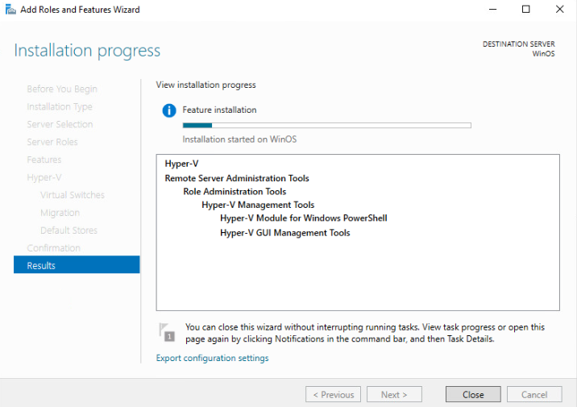

- 2.2 Create a New Virtual Machine using Hyper-V - Step 11 - Connect Virtual Hard Disk screen
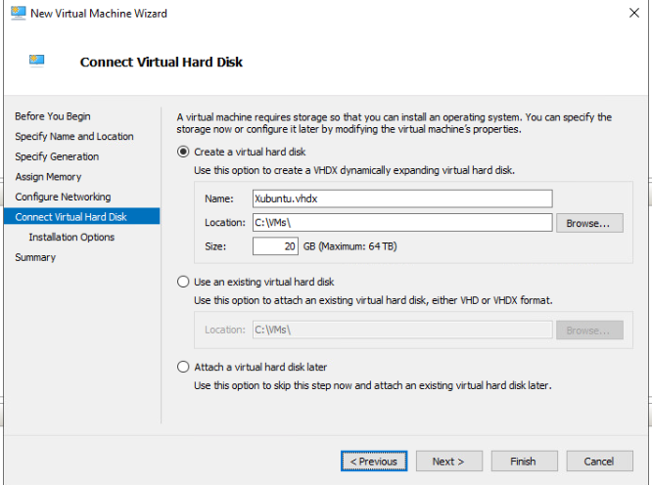
- 3.1 Install Guest OS - Step 9 - Newly created VM (Xubuntu)
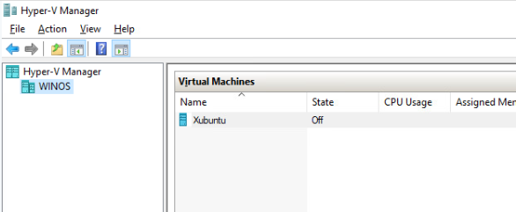

- 3.2 Install and Verify Xubuntu - Step 13 - Installation Complete
